RESOLUTION NO.__________

RE: CERTIFICATE OF APPROPRIATENESS UNDER THE
PROVISIONS OF THE ACT OF THE PENNSYLVANIA
LEGISLATURE 1961, JUNE 13, P.L. 282 (53
SECTION 8004) AND BETHLEHEM ORDINANCE NO.
3952 AS AMENDED.

The applicant proposes to install signage on the Book Shop Façade at
428-444 Main St.

NOW, THEREFORE, BE IT RESOLVED by the Council of the City of Bethlehem that a Certificate of Appropriateness is hereby granted for the proposal.

Sponsored by: (s)

(s)

ADOPTED BY COUNCIL THIS DAY OF

(s)
President of Council

ATTEST:

(s)
City Clerk

HISTORICAL & ARCHITECTURAL REVIEW BOARD

The applicant proposes to install signage on the Book Shop Façade at
428-444 Main St.

APPLICATION #7:

Moravian College
1200 Main St.
Bethlehem, PA 18018
OWNER:

__________________________________________________________________________

The Board upon motion by Phil Roeder and seconded by Connie Glagola adopted the proposal that City Council issue a Certificate of Appropriateness for the following:

- The lettering font shall match the “Moravian College” font and all letter are to be
powder coated metal.

2. “Moravian Book Store” shall be approx. 10” high letter in Tricorn Black and
“Est. 1745” shall be approx.. 8” high letters in Web Gray.

3. The store signage is to be approx.. 6” high letters in Powder Blue to match the
awnings.

4. The motion carried by a vote of 7 yes, 1 no.

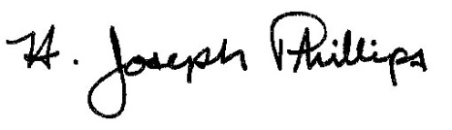 By:__H. Joseph Phillips___________

Title: __Historic Officer____________

Date of Meeting: November 7, 2018

